**Lake George Gem & Mineral Club**

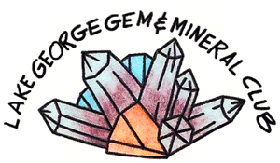PO Box 171

Lake George, Colorado 80827

[**www.LGGMclub.org**](http://www.LGGMclub.org)

January 15, 2018

Dear Gem & Mineral Dealer:

Greetings!

I am **Rebecca Blair**, the Lake George Gem & Mineral Club (LGGMC)’s 2018 Show Chair.

The 2018 **Lake George Gem and Mineral Show** will be Spectacular so *Reserve your Spot* Now!!

The show will be in its customary location on US Highway 24 (next to the Post Office)

In beautiful Lake George, Colorado

**August 17-18-19, 2018 Friday – Saturday – Sunday.**

As tradition, this is the 3rd full weekend of August, following the Contin-Tail show in Buena Vista Colorado.

* We will have our **Jump Start** this year! Only $10 per day to come early.
* Dealers can arrive to setup at noon the morning of Tuesday the 14th and everyone needs to be packed up & be **out NO LATER than noon on Monday August 20th**! Or late fees may be applied.

The Rates for 2018 are the same as last year (2-size space) format. Small space $70; oversized $90.

Please get your application in early, as we anticipate filling all the spaces. Applications will generally be approved in the order received. Should applications be received after all spaces are filled, dealers will be notified immediately, and their fees will be promptly returned.

Your accepted application will reserve a space up to Friday at noon on August 17tht at which time dealers who have not shown up or arranged for late set-up may be replaced by dealers on the waiting list, if any.

If you have questions or, after reserving a space, you cannot come (or may be arriving late), please contact me at the address, phone number or email address below.

I’m looking forward to seeing you this year!

Sincerely,

**Rebecca Blair**

Rebecca Blair, 2018 Show Chair

**Lake George Gem & Mineral Club**

117 Yucca Creek Road South

Divide, Colorado 80814

*phone:* 719-330-8123 email*:* [*blairra@hotmail.com*](mailto:blairra@hotmail.com)

**Lake George Gem & Mineral Club**

PO Box 171

Lake George, Colorado 80827

[**www.LGGMclub.org**](http://www.LGGMclub.org)

**2018 - Dealer Vendor Application**

*19 th Annual GEM and MINERAL Show*

**(Fri-Sat-Sun) AUGUST 17-18-19, 2018**

**Business Name: __________________________________________________**

**Name of Applicant: _______________________________________________**

**Address: ________________________________________________________**

**City: _____________________________ State: _______ Zip: ____________**

**Phone: (____) _____ - _________ Cell Phone: (____) _____ - _________**

**email Address: ___________________________________________________**

**Special Instructions/Contact for Emergency: ___________________________**

**Items offered for Sale: ________________________________________________**

**1st Choice of *Space* for 2018 Show: ___________ Next Choice(s) _________________** (ALL Spaces are 1st PAID 1st served). IF you are 35-feet, you MUST use a ‘Large’ space! Small Spaces (approx. 34’ long) are $70 *&* and Large Spaces (approx. 45’long) are $90.

Registration Fee $ _____________ $*70 small or $90 large {Setup THURSDAY 9 a.m.}*

JumpStart Fee is based on the day you move in!

Move-in Tuesday $______________ $20

Move-in Wednesday $______________ $10

**TOTAL: $ _______________**

*√* **By signing this application, you hereby agree**

**to The LGGMC Show Rules & Conditions:**

Signature: ___________________________________________ Date: ______/_____/________

* Please make your Check *payable* to: “**The Lake George Gem & Mineral Club**”



LAKE GEORGE GEM AND MINERAL SHOW

DEALER RULES and CONDITIONS (Page 1 of 2)

The ANNUAL LAKE GEORGE GEM AND MINERAL SHOW is a rock, mineral, fossil, *and related* items show. Items not related to the Lapidary Arts and Earth Sciences are **NOT** permitted. This includes flea market items, antiques, guns, etc.

Participation by vendors is permitted only on acceptance of the vendor's application by the Dealer Chairperson. Advance applications are strongly encouraged. Space is allocated to pre-registered vendors, with applications "at the gate" considered only on a "space available" basis.

No sales will be permitted by unregistered dealers, and sales will **NOT** be allowed outside the vendor area.

Any person selling at the LAKE GEORGE GEM AND MINERAL SHOW is required by law to obtain a single Event or multiple Events license. Licenses are available from the Colorado Department of Revenue, 1375 Sherman St., Denver, CO 80216-0013.

Any person selling at the LAKE GEORGE GEM AND MINERAL SHOW shall collect Sales Tax for the State of Colorado and Park County and remit the same to the Colorado Department of Revenue, 1375 Sherman St. Denver, CO 80261-0013, no later than the 20th day of the month following the Show.

The show registration fees are $70.00 for a Small Space or $90.00 for a Large Space per vendor. Each vendor must be paid in full before being permitted to move onto the show grounds. **For OVERSIZED RIGS (anything Over 35 foot) you MUST take the Large-format Space.** Each individual vendor is responsible for paying the appropriate fee, even if sharing a space with another vendor. A ‘Jump Start’ fee payment allows the applicant to set up prior to the show opening no earlier than Noon on Monday, Aug. 13th, local Mountain Time (move in: Monday-$40, Tuesday-$30, Wednesday-$20). Thurs.+ included in Space Fee

All vendors must check in upon arrival to obtain their space assignment.

* Space Assignment is on a ***1st-Paid/1st -Served*** Basis. At the end of the Show, you will be offered your space or best available for the following year, at the Current charge rates. (**Note**: Some were ‘paid for’ last year).

This is an "open air" show. No power, running water or shelter is provided. "Dry" camping is permitted for registered dealers, and sufficient space is available for parking RV's (one per registered vendor). Portable toilets will be available for dealers and the public. A diligent effort will be made to arrange for one or more food vendors "on site".

MC900104742[1]

**No generators allowed running after 10 PM or before 7 AM. *This means QUIET TIME is from 10pm to 7am!!***

**No camping is allowed outside the vendor area in town. Please camp ONLY in approved designations.**



**All cooking will be in approved Grills ONLY. No fires or charcoal on the ground.** 

MC900389178[1]

**The South roped-line along the power line is a “hard-line ". NO EXCEPTIONS! Anyone trespassing will be required to leave the show immediately! (Violations of this rule can jeopardize us having the Show at this location!!)**

***All pets must be kept on a leash*.** Pet owners are responsible for their animals at ALL times.

LAKE GEORGE GEM AND MINERAL SHOW

DEALER RULES and CONDITIONS (Page 2 of 2)

MC900053977[1]Prompt cleanup of waste is required. All vendors and campers are responsible for policing and removing trash from their areas. A location will be designated for trash disposal**.**

* Any additional rules determined by the hosts to be necessary for the safe and efficient operation of the Show shall be posted at the Show Host table near the entrance gate.



**By application for participation in the show, all vendors agree to observe any & all such posted rules.**

* Anyone in violation of said rules or behavior deemed unsafe or detrimental to the orderly operation of the ANNUAL LAKE GEORGE GEM AND MINERAL SHOW may be asked to leave, and may be disqualified from future participation.

**Acceptance of Rules and Conditions:**

Signature. ____________________________________________________

Date: _________________________

This event is sponsored by the LAKE GEORGE GEM & MINERAL CLUB, a Colorado *not for profit* corporation, and a member of the Rocky Mountain Federation of Mineral Societies. Written inquires may be directed to

**LAKE GEORGE GEM AND MINERAL CLUB**

**P.O. BOX 171**

**LAKE GEORGE, CO 80827**

The LGGMC Show contact person for the August 2018 show is Rebecca Blair, 719-330-8123, blairra@hotmail.com

Lake George Gem & Mineral Club

ATTN: Rebecca Blair, 2015 Show Chair

P.O. Box 171

Lake George, CO 80827

**Lake George**

**Gem & Mineral Club**

**2018 Annual Show**

Dealer Packet

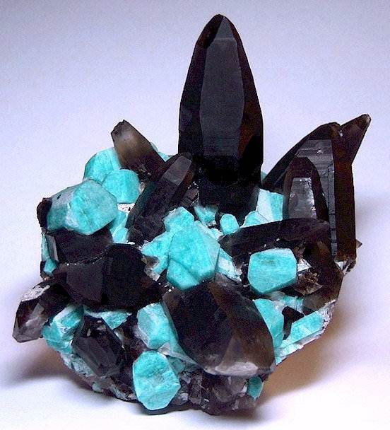

August 17-19, 2018